**WEEKLY REPORT DE BENEDETTI MATTEO**

**WEEK 17: 06/01/2020 - 10/01/2020**

AUTONAV TEST:

I worked with a colleague to run an autonav test using the SpartanVO with IMU as localization, achieving good results in the pose estimate.



Figure 1: Autonav test trajectory



Figure 2: Autonav test, position error



Figure 3: Autonav test, orientation error

LOCCAM VS NAVCAM ON L-SHAPED TRAJECTORY

A test in a more complex trajectory has been run to compare the LocCam and NavCam VOs. The NavCam VO has clearly a larger final error, it has error spikes along the trajectory and a position drift during the point turn, as opposed to the LocCam estimation which is considerably smoother during the translation and with no drift in the point turn.



Figure 4: NavCam vs LocCam L-trajectory test, trajectory



Figure 5: NavCam vs LocCam L-trajectory test, position error



Figure 6: NavCam vs LocCam L-trajectory test, orientation error

TERRAIN TESTS:

More tests were executed to get a better insight in the differences between the LocCam and NavCam VO.  
For both cameras a 3.5 meters long traverse at 0.07 m/s was compared with 2 other interesting sequences:

* Rocks: small pebbles were placed in the rover’s path to evaluate the effect of the mast vibrations when the rover moves over them.   
  In order to avoid a possible positive effect of adding more features, the rocks were buried in the sand.

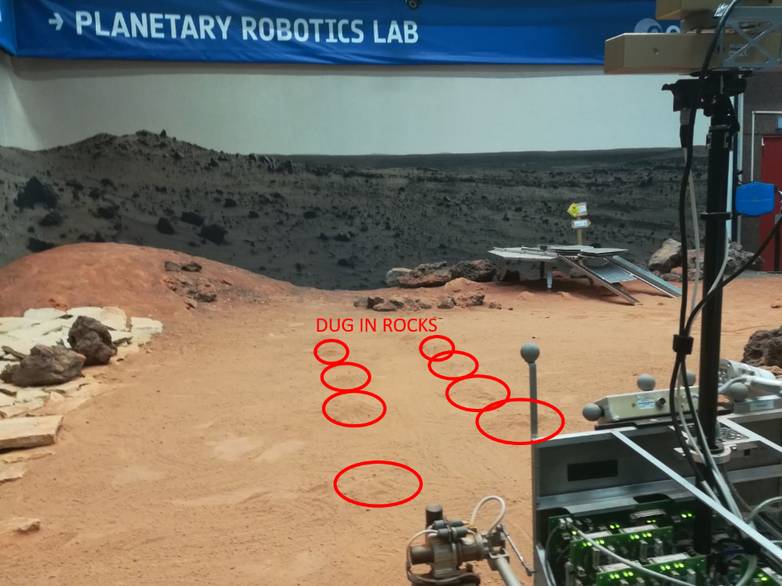

Figure 7: Terrain for the rocks test

* Near Tables: the rover moves parallel to the tables and various equipment in the lab, this has the effect of adding a considerable amount of close features, though only on one side, that the NavCam was missing before.

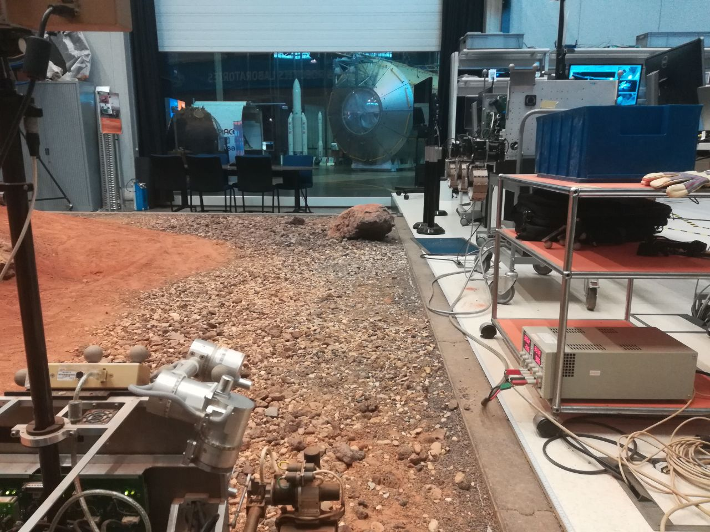

Figure 8: Terrain for the test near the tables



Figure 9: NavCam terrain tests

Figure 10: LocCam terrain tests

The LocCam performed very similarly in all 3 sequences, with a small decrease in accuracy in the rocks traverse compared to the normal sand traverse.

The NavCam instead showed considerably lower performances with a steeper error curve in the rocks sequence, while the near tables sequence gave a small increase in accuracy.

These tests may confirm that the main reason for the worse performances in the NavCam VO is indeed induced by the vibration of the mast while the rover moves and the lack of close features due to the NavCam position on top of the mast.

NEW TASKS:

The previous tests marked the end of the VO testing activity, so I discussed what to do next with my supervisor and we defined two activities:

1. SLAM Integration: Work on implementing the SpartanVO and mapping in a bigger SLAM architecture [1], already developed in the lab by other colleagues, as shown in the picture.  
   If the time, and more importantly the weather, allow it, the plan would then be to perform a field test in a location near ESTEC, where it is possible to perform a traverse of the order of 100m rather than the few meters of the Laboratory mars terrain.

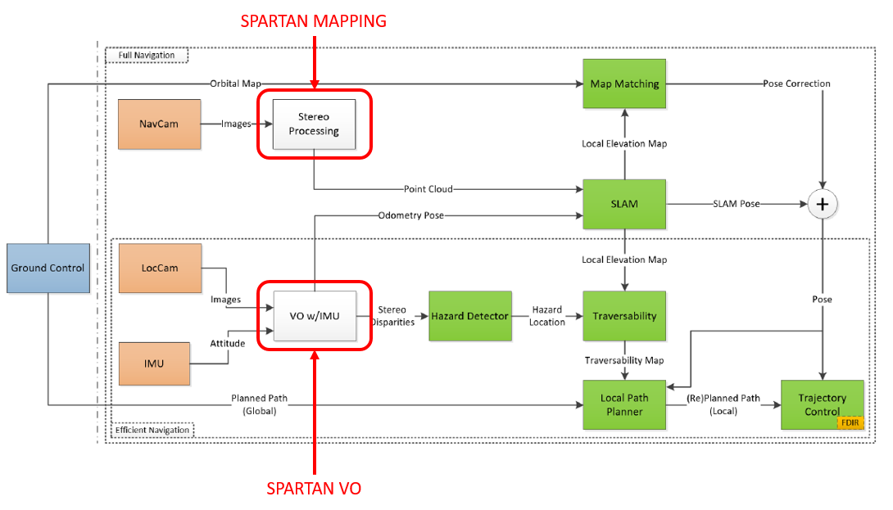

1. GNC Commissioning: As a minor side project I will also work on defining, and possibly test, a procedure to commission the GNC in the scenario of the ExoMars landing.

SLAM INTEGRATION:  
I started looking at the various scripts that implement the scheme in the figure above to get an idea of how to connect the existing Spartan components, both VO and mapping, to the others.

GNC COMMISSIONING:

I started thinking about the GNC commissioning procedure, so far I only brainstormed some ideas that are still very far from being a procedure and started organizing them according to the rover state: just landed and still on the lander platform, on the lander ramps, on the ground near the lander

Rover on the lander

* Test cameras
* Test ptu for navcam
* Test localization sensors and components individually:  
  imu, visodom, slam, mapping, wheels encoders
* Test localization drift when stationary
* Test mapping aiming at the rover/lander and compare it with known models
* Test wheels deployment motors:  
  deploy wheels and check increase in elevation and correct orientation with imu (change in roll and pitch may indicate a problem in one or more wheels)
* Test wheels motors:  
  very short traverse, check wheels rotation visually with navcam and rover position with VO
* Test turning motors:  
  turn the wheels and check wheels rotation with rover navcam where possible (solar panels might be in the way) and landers cam if available
* Test Point turn:  
  check orientation with imu
* Test short traverse:  
  check localization wheel odometry (assume slip ratio to be 0 on the lander?)

Rover descending on the ramps

* Test short traverse on the ramps

Rover on the ground near the lander

* Test short traverse compare localization with lander cameras
* Perform a complete point turn to check localization and also visual inspection of the rover with lander cameras
* Test an Ackermann turn
* Manually identify obstacles and test the obstacle detection
* Test then obstacle avoidance

FUTURE OBJECTIVES:

Regarding the VO test, I will have a quick discussion with my internal supervisor to see if the conclusions I drew from the terrain tests are valid and if with this the testing activity is actually closed.

For the SLAM integration of Spartan I plan to discuss it with also the other lab mates involved in the project, for now I looked at the current script which uses either Vicon or the GPS.

Finally, for the GNC Commissioning I intend to talk about it with my internal supervisor to see if more should be added and eventually start to turn it into an actual procedure

BIBLIOGRAPHY:

[1]: “A GNC Architecture for Planetary Rovers with Autonomous Navigation Capabilities” Martin Azkarate, Levin Gerdes, Luc Joudrier and Carlos J. Pérez-del-Pulgar.